Brandon Hobbs

CS-340

September 14, 2022

**Module 3**

# Part I

**Prompt 1: Import CSV**



**Prompt 2: After importing your data set, start up the mongo shell. Create a simple index on the key “breed”. Show an example query that will use this index and verify that the index will be used with the explain function**

**Prompt 3:** **Create a compound index** **that will improve the performance of queries looking for breeds that have an “outcome_type” of “Transfer”.**

Or a partial filter could be used instead of the “nested doll” method

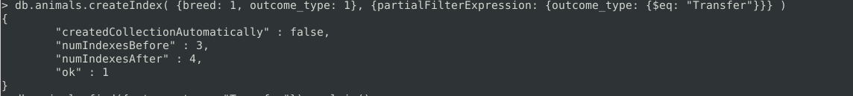

# Part II

**Prompt 1:**

**Create an administrator account in the mongo shell by following steps #2–3 of the MongoDB Manual Enable Access Control tutorial. Then exit the mongo shell.**

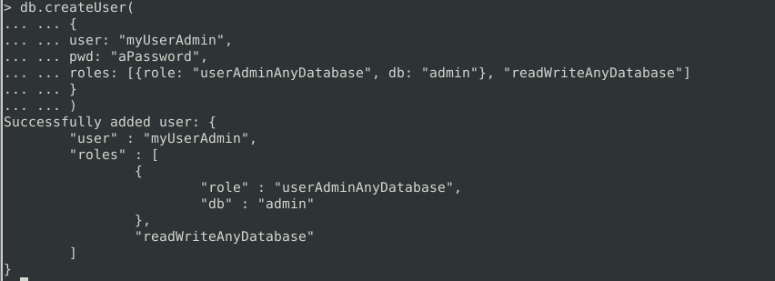

**Prompt 2: Enable user authentication for the database**

**Prompt 3: Create a new user account called “aacuser”**

**Prompt 4: Take a screenshot of your login process to MongoDB using the mongo shell. Be sure you can access MongoDB and list the databases using both the admin and aacuser accounts**

